Overview of the Organization

Palestinian Wastewater Engineers Group (PWEG)

Palestinian Wastewater Engineers Group (Palestine): Is a technical non-governmental and non-profit making organization that was established in 2002. PWEG is a key player in several working groups and committees for the formulation and adoption of adequate water and environmental management standards in communities and governorates of Palestine. We campaign and engage decision-makers to improve access to water and sanitation in Palestine. Our projects aim to enhance the technical, managerial, financial and legal capacities of Palestine.

As our slogan is ‘Clean Environment’ we are dedicated to improving water supply and sanitation services across Palestine and the region by providing practical solutions to address water scarcity, improve water security and delivering permanent and sustainable benefits to our beneficiaries. PWEG had been the first organization in the country to successfully reuse treated wastewater in protected agriculture under greenhouses using drip irrigation systems. Moreover, PWEG has a strong experience in renewable energy being the first organization in the country to design, implement and license grid tied PV systems used to run deep artesian wells’ pumps.

The organization’s key data is summarized as follows:
Address: Al-Bireh, Ramallah / Palestine.
Established: 2002
Registration Number: RA-22330-SC.
Managing Director: Monther Hind
www.palweg.org
www.facebook.com/PALWEG
PWEG@PWEGPal

Logo:
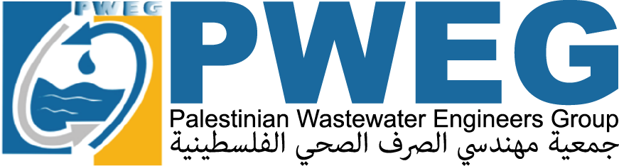

We are governed by a Board of Directors. The Board helps to direct our services and oversees the senior management team, who are responsible for PWEG’s day-to-day performance. Directors are experts in their relevant field, with expertise in wastewater engineering, economics and management. In addition to this, partners of universities, technical and scientific institutions – working for years for the organization – are supporting our project team according to requirements. We distinguish ourselves through our motivated staff. PWEG works with its own staff, freelance experts and other companies as subcontractors in order to strengthen each project team.
Development Section
Legal Support
Engineering Department
Projects Department

Accounting Department
HR Department
Secretarial Support
Administrative Department
Board of Directors
General Assemble
The principal organisational chart of PWEG is shown below:
General Assemble
Board of Directors
Administrative Department
Secretarial Support
HR Department
Accounting Department
Projects Department

Engineering Department
Legal Support
Development Department

PWEG’s main target group is the local authorities including Joint Service Councils, municipalities, local communities and village councils. Wastewater utilities and Palestinian consulting engineering firms also benefit from PWEG activities along with other organizations working in the environmental sector. The Palestinian Water Authority and Ministry of Local Government also benefit from our services.

The major field of PWEG’s activities are illustrated hereinafter:

- Water supply and wastewater master plans.
- Water supply networks.
- Reservoirs and tanks.
- Wastewater collection networks.
- Storm water networks.
- Pumping stations.

WATER & WASTEWATER INFRASTRUCTURE

- Drinking water protection.
- Wastewater treatment plants.
- Sludge treatment.
- Reuse of treated wastewater.

WATER & WASTEWATER TREATMENT

- Drainage master plan.
- Gabions.
- Springs rehabilitation.
- Irrigation.
- Water management.
HYDRAULIC WORKS

- Grid tied photovoltaic systems.
- Off grid photovoltaic systems.

RENEWABLE ENERGY

- Creation of Water and Wastewater Departments.
- Creation of Water and Sanitation Joint Council.
- Strengthening the Joint Service Council’s capacitates for SWM.
- Environmental Policies
- Public Awareness.
- Community Participation Campaign.
- Institutional capacity building.
CAPACITY BUILIDING

- Solid Waste Management.
- Assessment of Solid Waste Management.
- Time and motion.
- Recycling and composting.
SOLID WASTE

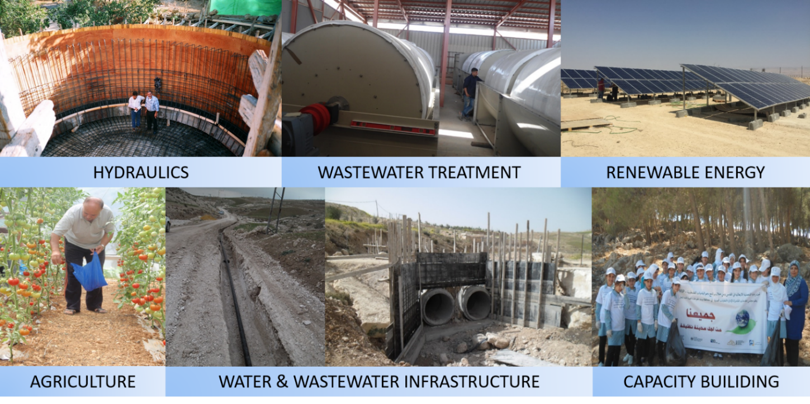
PWEG’s main mission is to protect the environment by providing different services as presented below;
TECHNICAL ASSISSTANCE
PROJECT MANAGEMENT and ENGINEERING

- Design.
- Tender documents.
- Tender procedures.
- Bids evaluation.
- Design review.
- Works supervision.
- Commissioning supervision.

STUDIES

- Assistance for organization and planning.
- Assistance for technical, regulatory and financial follow up and monitoring.
- Assistance for project management.
- Operation and maintenance assessment.

- Water and sanitation assessment studies.
- Water and sanitation feasibility studies.
- Tariff studies and tariff by laws.
- Procurement capacity building.
- Institutional studies and capacity building.
- Legal and regulatory capacity building.
- Master plans.
- ESIA programs.

